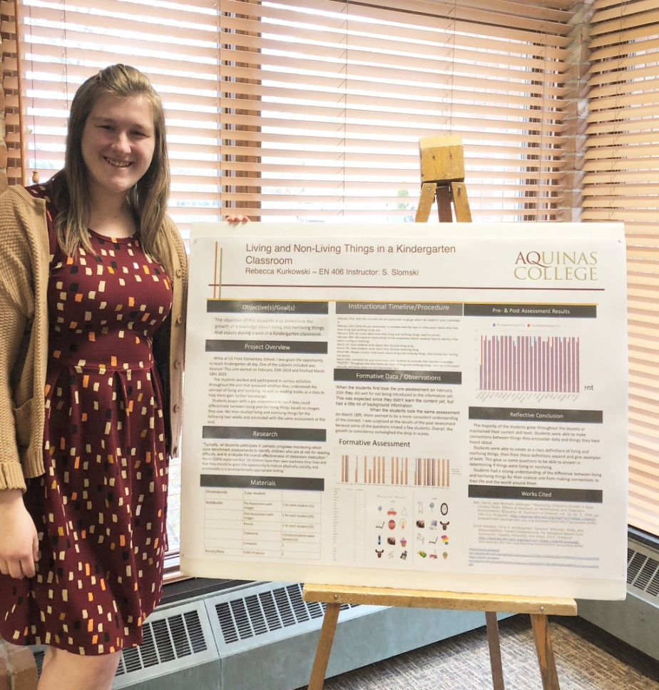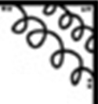

Hello! I am so excited to be your teacher this year at Fieldcrest Elementary! This is my third year teaching! I studied Elementary Education, Early Childhood Education, and Learning Disabilities! This year I look forward to working with each and every one of you to reach our goals in a safe and welcoming environment!



Drink: Starbucks!

Food: Chicken or Hamburgers

Snack: Doritos or Veggie Chips

Movie: Any Romantic Comedy

Show: Anything Gordan Ramsey!

Email: [rkurkowski@phsd144.net](mailto:rkurkowski@phsd144.net)

Phone ext: 2611

Miss Kurkowski’s Favorites

Contact Info

**Welcome to Kindergarten!**

**Miss Kurkowski**

**Meet**